Pinterest full HD video downloader

## **Introduction**

Pinterest is a popular social media platform where users can discover and save ideas for many projects and interests. Looking to elevate your Pinterest experience? Look no further! Introducing [**Pinmate.online**](https://pinmate.online/) your ultimate destination for unlocking the full potential of Pinterest with our HD video downloader. One feature that many users find valuable is the ability to download full HD videos from Pinterest. Experience Pinterest like never before with PinMate.online's user-friendly interface and supreme HD video downloading capabilities. In this article, we will explore what a Pinterest full HD video downloader is, how to use it, its benefits, and address some frequently asked questions.

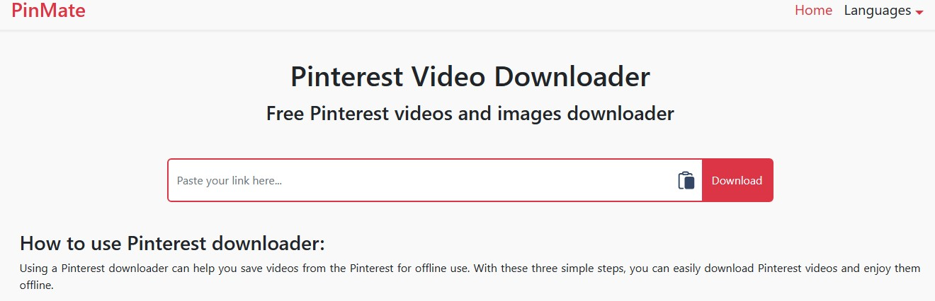

## **What is Pinterest full HD video downloader?**

A Pinterest full HD video downloader is a tool that allows users to save high-definition videos from Pinterest onto their devices. This tool enables users to access their favorite videos offline, share them with friends, or use them for creative projects. By using a Pinterest full HD video downloader, users can easily download videos in the best quality available on the platform.

## **Why Choose Our Full HD Video Downloader?**

**High-Quality Downloads:** With our downloader, you can graze goodbye to low-resolution videos. We prioritize quality, offering full HD downloads that are crisp, clear, and visually gorgeous.

**Usability:** We made our downloader as simple to use as possible. With just a few clicks, you can save any Pinterest video to your device, ready to be enjoyed offline whenever you want.

**No Cost:** Best of all, our Pinterest Full HD Video Downloader is completely free to use. Everyone can use it because there are no subscription costs or unstated costs.

## **How to Use Pinterest Full HD Video Downloader**

Pinterest has become a go-to platform for discovering and sharing visual content. Whether you're into home decor, recipes, or fashion, there's always something inspiring to find. And with the growing popularity of video content, Pinterest now allows users to [**download full HD videos**](https://pinmate.online/). Here's a simple guide on how to use Pinterest Full HD Video Downloader effectively.

### **Step 1: Find the Video You Want to Download**

Browse through Pinterest and find the video you wish to download.

To view the video in full screen, click on it.

### **Step 2: Copy the Video Link**

Tap on the three-dot icon in the bottom right corner of the video.

Select the "Copy link" option to copy the video link to your clipboard.

### **Step 3: Use the Video Downloader**

Open a new browser tab.

Search for a reliable Pinterest Full HD Video Downloader.

Paste the copied link into the downloader tool and click "Download."

### **Step 4: Download and Save the Video**

Select where you want to save the video on your device after the download is finished.

Enjoy watching the full HD video offline anytime you want!

## **Benefits of Using Our Pinterest Full HD Video Downloader:**

**Improved Viewing Experience:** Enjoy your favorite Pinterest videos in stunning clarity and detail with full HD resolution.

**Convenience:** Save videos to your device for offline viewing, so you can watch them anytime, anywhere, even without an internet connection.

**No More Protecting:** Say goodbye to buffering issues and interruptions. Downloading videos in full HD ensures smooth playback without any lag.

**Unlimited Downloads:** With our downloader tool, there's no limit to the number of videos you can download. Meet as many as you like and add them to your own collection.

**User-Friendly Interface:** Our downloader features a simple, intuitive interface that makes downloading Pinterest videos a breeze. It's simple to use whether you're a tech expert or not.

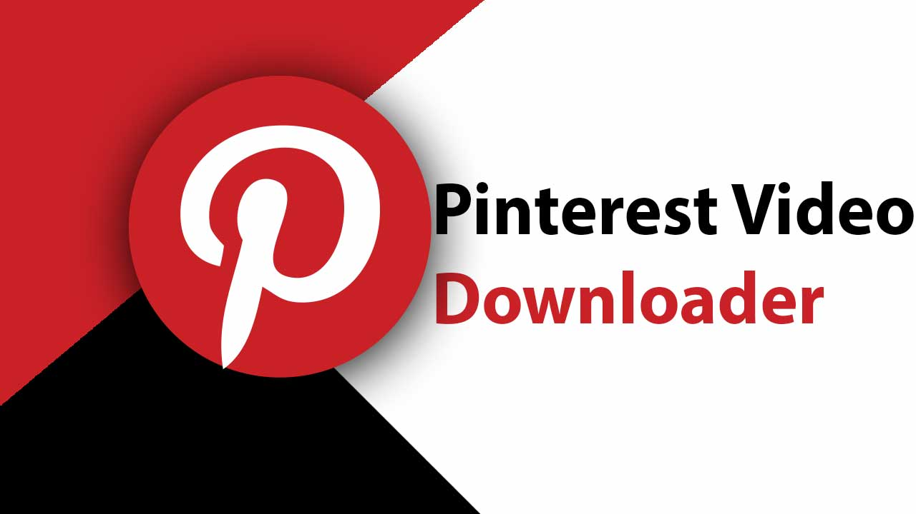

## **Conclusion**

In conclusion, a Pinterest full HD video downloader is a valuable tool for users who want to save and access high-definition videos from Pinterest. By following simple steps, users can download their favorite videos and enjoy them offline or share them with others. The benefits of using a Pinterest full HD video downloader are numerous, making it a convenient and practical tool for Pinterest users. Downloading full HD videos from Pinterest can be a convenient way to save and share your favorite content. However, it is essential to do so ethically and in compliance with copyright laws. By using reputable video downloader tools and following proper guidelines, you can enjoy high-quality videos from Pinterest responsibly.

**For more information click on this link:** [**https://articlescad.com/pinterest-video-to-mp4-downloader-52127.html**](https://articlescad.com/pinterest-video-to-mp4-downloader-52127.html)

## **Faqs (frequently asked question)**

### **What is a Pinterest Full HD Video Downloader?**

A Pinterest Full HD Video Downloader is a tool that allows you to save high-definition videos from Pinterest onto your device for offline viewing.

### **What video quality can I expect?**

With our downloader, you can expect to download Pinterest videos in stunning full HD quality, providing you with the best viewing experience.

### **Does installing any software or extensions need to be done?**

No, our Pinterest Full HD Video Downloader is an online tool that requires no installation or additional software. Simply visit our website and start downloading your favorite Pinterest videos instantly.

### **Is there a maximum amount of videos I can download?**

No, there are no limits. You can download as many Pinterest videos in full HD quality as you want, whenever you want.

### **How to download full HD videos from Pinterest?**

To download full HD videos from Pinterest, you can use various online tools or browser extensions specially designed for this purpose. One popular tool is the Pinterest Video Downloader, which allows you to easily download high-quality from Pinterest by simply and pasting the link.

### **Is legal to download videos Pinterest?**

It important to note that videos from Pinterest without permission of the content may infringe on copyright. While some videos Pinterest may be available for download with the creator's consent, it is always best to respect intellectual rights and obtain permission before downloading and using any content.

### **Can I download Pinterest videos on mobile devices?**

Yes, you can download Pinterest videos on mobile devices using certain apps or websites that are compatible with mobile browsers. Simply copy the video link from Pinterest, paste it into the video downloader tool, and select the desired video quality for download.

### **How to ensure the video quality is full HD?**

To ensure that you are downloading full HD quality videos from Pinterest, make sure to select the highest available video quality option when using a video downloader tool. Additionally, check the video resolution and file size before downloading to ensure that you are getting the best quality possible.